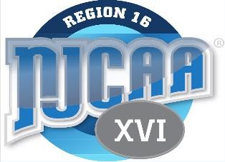
REGION XVI SPORT CODE
2024-2025
Men and Women’s Track and Field

Sport: Men’s Track and Field
Chair: Steve Davis - MAC
AD Liaison: Jim Gerwitz
Division: Division I & III
Regional Tournament Dates: None
Regional Tournament Sites(s): None

- Regular Season Competition: Regional schools are not required to compete against each other during the regular season.

- Region XVI Championship Determination: Region champion shall be determined by the highest point total based on the seasons best marks. At the end of the season, head coaches will compare season best marks in each national event either team has competed in. When scoring uncontested events, a team is allowed a maximum of 3 athletes counting towards the overall team score. Only one relay shall be counted per team per event. Head coaches will determine the season best marks based on a point total as follows: 1st = 10, 2nd = 8, 3rd = 6, 4th = 5, 5th = 4, 6th = 3, 7th = 2, 8th = 1.

- Team Awards: One (1) Region XVI Championship plaque shall be awarded to the team with the highest team score based on the Region XVI Championship Determination.

- Individual Awards: Five (5) All-Region plaques will be awarded based on the below (#1 is the primary method. 2-4 are the numerous tie breakers):
  - Each head coach will rank their top four (5) Track & Field athletes in order.
  - Coaches shall discuss any discrepancies and try to reach an agreement.
  - Coaches will compare quality and quantity of national rankings.
  - Regional points scored.

- Code of Conduct: The region will abide by the Code of Conduct as stated in the NJCAA Handbook and Casebook.

- National Meet Qualification: Region XVI relay teams and individuals can qualify for the NJCAA National Meet based on their season best marks as listed on the NJCAA website.

- Region XVI Coach of the Year: The team with the highest point total listed in the
Region XVI Championship guidelines will be awarded to that Coach – No plaque

